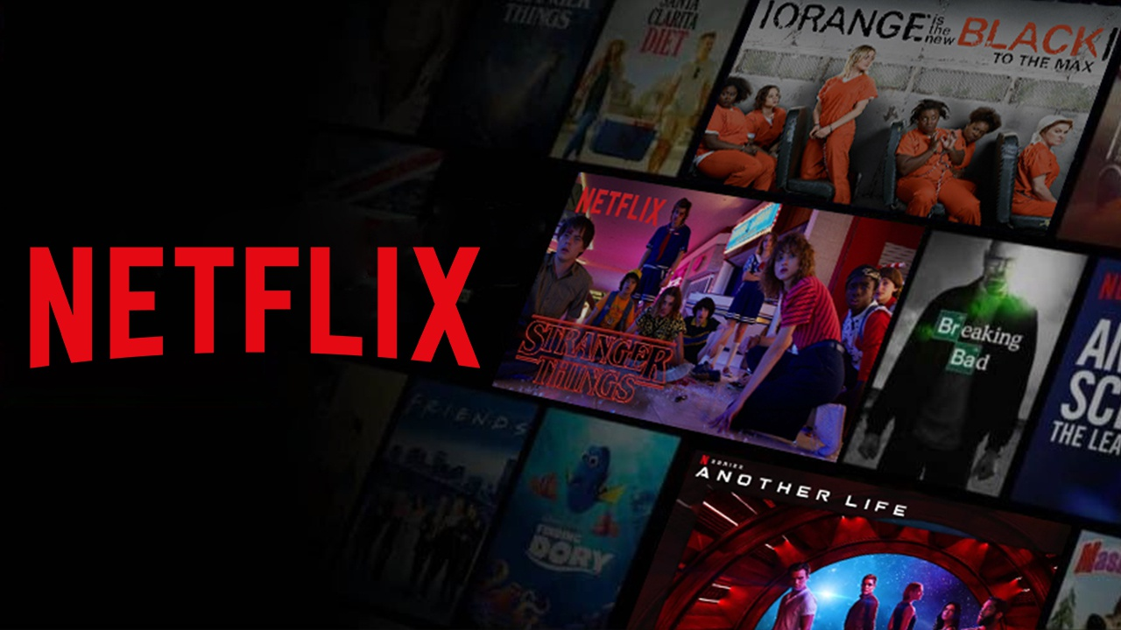

**Product Dissection for Netflix**

##### **Contribution** - Individual

##### **Name** - Kashmira Kor

### **Company Overview:**

Founded in 1997 by Reed Hastings and Marc Randolph, Netflix ([Netflix.com](https://www.netflix.com/)) is a global entertainment juggernaut that has revolutionised how people consume content. Boasting an extensive library of movies, TV shows, documentaries, and original productions, Netflix stands out for its personalised recommendations, driven by cutting-edge algorithms. The platform's emphasis on on-demand streaming has reshaped viewing habits, allowing users to dictate when and what they watch. With a commitment to innovation and a global reach that transcends borders, Netflix has become an integral part of modern entertainment, setting the standard for streaming services worldwide.

### **Product Dissection and Real-World Problems Solved by Netflix:**

Netflix, at the forefront of the streaming industry, has not only navigated challenges but has transformed them into opportunities for innovation. One of its standout strategies is a meticulous understanding of user preferences. Through sophisticated algorithms, Netflix analyses viewing habits and tailors recommendations, ensuring that each subscriber discovers content aligning with their unique tastes. This personalised approach not only enhances user satisfaction but also fosters a sense of discovery, exposing audiences to a diverse array of genres and stories they might not have encountered through traditional media.

In addressing the demand for diversity in content, Netflix has emerged as a champion. The platform has actively sought and produced a vast array of original programming, showcasing stories from different cultures, perspectives, and genres. This commitment to content diversity not only reflects the evolving landscape of global entertainment but also resonates with a wide and varied audience. By offering a rich tapestry of narratives, Netflix has become a cultural melting pot, catering to the diverse tastes and preferences of its ever-expanding subscriber base.

Moreover, Netflix has tapped into and embraced the binge-watching culture that has become synonymous with modern streaming. The release of entire seasons at once caters to the desire for immersive and continuous storytelling. This binge-friendly model has not only altered how audiences consume content but has also shaped the expectations and habits of viewers, contributing to the platform's cultural impact. Through a combination of user-centric strategies, content diversity, and an embrace of binge-watching, Netflix stands as a trailblazer that has effectively addressed and redefined the challenges within the entertainment landscape.

### **Case Study: Real-World Problems and Netflix's Innovative Solutions**

Netflix, a leading streaming platform, has not only disrupted traditional entertainment consumption but has also addressed significant real-world challenges through its innovative features. By understanding user behaviour and leveraging technology, Netflix has positioned itself as a user-centric platform that caters to individual preferences, encourages content diversity, and transforms the viewing experience.

#### **Problem 1: Overwhelming Content Choices**

**Real-World Challenge:** With an abundance of content available, users often struggle to find movies and TV shows that align with their interests, leading to decision fatigue.

**Netflix's Solution:**

Netflix addresses the issue of overwhelming choices by implementing a sophisticated recommendation algorithm. By analysing users' viewing history, preferences, and ratings, the platform offers personalised recommendations. This intelligent system helps users discover content tailored to their tastes, simplifying the decision-making process and enhancing the overall user experience.

#### **Problem 2: Fragmented Viewing Experience**

**Real-World Challenge:** Traditional TV broadcasting often results in a fragmented viewing experience, with scheduled programming and limited content options.

**Netflix's Solution:**

Netflix provides a seamless, on-demand streaming experience, allowing users to watch content whenever and wherever they want. By eliminating the need for a fixed schedule, users can binge-watch entire seasons, creating a continuous and immersive viewing experience. This approach caters to the evolving preferences of modern audiences and solves the problem of a fragmented viewing experience.

#### **Problem 3: Lack of Content Diversity**

**Real-World Challenge:** Traditional media outlets may have limited diversity in content, often excluding niche genres and underrepresented voices.

**Netflix's Solution:**

Netflix addresses the need for content diversity by investing heavily in original content production. The platform creates and acquires a wide range of content, including international films, documentaries, and original series that cater to diverse tastes and cultural backgrounds. This commitment to inclusivity solves the problem of limited content diversity, offering a rich and varied entertainment selection.

#### **Problem 4: Inefficient Content Discovery**

**Real-World Challenge:** Users struggle to efficiently discover new content that aligns with their preferences, leading to missed opportunities for exploration.

**Netflix's Solution:**

Netflix employs a user-friendly interface with features like "Trending Now" and "Top Picks for You." These sections showcase popular and recommended content based on individual preferences, making content discovery more efficient. Additionally, the platform's categorization and genre-specific recommendations help users explore new titles, solving the problem of inefficient content discovery.

#### **Problem 5: Content Expiration and Limited Access**

**Real-World Challenge:** Users often face the frustration of content being removed from streaming platforms due to licensing agreements, limiting access to their favourite shows and movies.

**Netflix's Solution:**

Netflix addresses the issue of content expiration by focusing on producing a substantial amount of original content. By investing in a diverse library of exclusive and original shows and movies, Netflix ensures a constant influx of new and unique content. This strategy minimises the impact of content removals and provides users with a broad range of options, reducing the disappointment associated with limited access to favourite titles.

#### **Problem 6: Multilingual Audience Engagement**

**Real-World Challenge:** Traditional media platforms may struggle to cater to a multilingual audience, leading to a lack of accessibility for viewers who prefer content in different languages.

**Netflix's Solution:**

Netflix has prioritised inclusivity by providing subtitles and dubbing options for a wide array of languages. This feature enhances the accessibility of content for users around the world, allowing them to enjoy movies and TV shows in their preferred language. By addressing the challenge of language barriers, Netflix has expanded its global reach and made its platform more welcoming to diverse audiences.

#### **Problem 7: Ineffective Parental Controls**

**Real-World Challenge:** Parents often encounter difficulties in controlling the content accessed by their children, leading to concerns about age-appropriate viewing.

**Netflix's Solution:**

Netflix tackles the challenge of effective parental controls by offering robust settings that allow parents to customise their children's viewing experience. Parents can set up age restrictions, create individual profiles for each family member, and control the types of content accessible to different age groups. This approach ensures a safer and age-appropriate streaming environment, addressing the concerns of parents and enhancing family-friendly usage of the platform.

#### **Problem 8: Offline Viewing Limitations**

**Real-World Challenge:** Users may face limitations in accessing content offline, particularly in areas with poor or no internet connectivity.

**Netflix's Solution:**

Netflix addresses the challenge of offline viewing limitations by allowing users to download select shows and movies for offline viewing. This feature is especially beneficial for users in areas with unreliable internet access or during travel. By providing offline access to a portion of its library, Netflix caters to the diverse needs of its user base and ensures uninterrupted entertainment experiences.

#### **Conclusion:**

Netflix's success in the streaming industry is a result of its ability to understand and address real-world challenges in the entertainment landscape. By providing personalised recommendations, promoting binge-watching culture, investing in diverse content, and optimising content discovery, Netflix has transformed the way audiences consume entertainment. This case study highlights how Netflix's user-centric approach has positioned it as a leader in the digital streaming domain, offering practical solutions to the evolving needs of a global audience.

### **Top Features of Netflix:**

1. **Personalised Recommendations:** Netflix analyses user preferences and viewing history to provide personalised movie and TV show recommendations.
2. **Seamless Streaming:** Users can watch content on-demand, without the constraints of a fixed schedule, allowing for a seamless and immersive viewing experience.
3. **Original Content Production**: Netflix invests in producing and acquiring a diverse range of original content, including movies, series, documentaries, and international titles.
4. **Binge-Watching Culture:** The platform encourages binge-watching by releasing entire seasons at once, allowing users to consume content at their own pace.
5. **User-Friendly Interface:** Netflix's interface includes sections like "Trending Now" and "Top Picks for You" to enhance content discovery and provide efficient navigation.
6. **Dynamic Watchlists:** Users can create dynamic watchlists that evolve based on their viewing habits and preferences. The watchlist adapts to changes in user interests, ensuring that recommended content is always relevant and up-to-date.
7. **Virtual Watch Parties:** Netflix enables users to host virtual watch parties, allowing friends and family to synchronise their viewing experience and interact through a chat feature, creating a shared entertainment experience even when physically apart.
8. **Storyline Exploration:** Netflix introduces a storyline exploration feature for select shows, providing alternate storylines or endings that users can explore. This interactive storytelling adds an extra layer of engagement to certain series, offering a unique and personalised viewing experience**.**

### **Schema Description:**

The schema for Netflix involves multiple entities that represent different aspects of the platform. These entities include Users, Shows, Movies, Genres, Recommendations, and more. Each entity has specific attributes that describe its properties and relationships with other entities.

**User Entity:**

Users are at the core of Netflix. The user entity contains information about each user:

* **UserID (Primary Key):** A unique identifier for each user.
* **Username:** The chosen username for the user's account.
* **Email:** The user's email address for account-related communication.
* **Subscription_Type:** Information about the user's subscription plan (e.g., Basic, Standard, Premium).
* **Subscription_Start_Date:** The date when the user started their subscription.

**Show Entity:**

Shows represent TV series available on Netflix:

* **ShowID (Primary Key):** A unique identifier for each show.
* **Title:** The title of the TV series.
* **GenreID (Foreign Key referencing Genre Entity):** The genre associated with the show.
* **Release_Date:** The date when the show was released.

**Movie Entity:**

Movies represent individual films available on Netflix:

* **MovieID (Primary Key):** A unique identifier for each movie.
* **Title:** The title of the movie.
* **GenreID (Foreign Key referencing Genre Entity):** The genre associated with the movie.
* **Release_Date:** The date when the movie was released.

**Genre Entity:**

Genres categorise shows and movies:

* **GenreID (Primary Key):** A unique identifier for each genre.
* **Name:** The name of the genre (e.g., Action, Drama, Comedy).

**Recommendation Entity:**

Recommendations store personalised suggestions for each user:

* **RecommendationID (Primary Key):** A unique identifier for each recommendation.
* **UserID (Foreign Key referencing User Entity):** The user receiving the recommendation.
* **ShowID (Foreign Key referencing Show Entity):** The recommended TV series.
* **MovieID (Foreign Key referencing Movie Entity):** The recommended movie.
* **Date_Created:** The date when the recommendation was generated.

**Watch History Entity:**

Watch History stores the movies/shows watched for each user:

* **WatchHistoryID (Primary Key):** A unique identifier for each entry in the watch history.
* **UserID (Foreign Key referencing User Entity):** The user who watched a specific show or movie.
* **ShowID (Foreign Key referencing Show Entity):** The watched TV series.
* **MovieID (Foreign Key referencing Movie Entity):** The watched movie.
* **Watch_Date**: The date and time when the user watched the show or movie.

**Device Entity:**

Device stores the device information user logged in:

* **DeviceID (Primary Key):** A unique identifier for each device used by a user.
* **UserID (Foreign Key referencing User Entity):** The user who owns the device.
* **Device_Type:** The type of device (e.g.Smart TV, Smartphone, Tablet).
* **Last_Used:** The date and time when the device was last used.

**Relationships are:**

* **Users receive Recommendations** – Each user can receive multiple recommendations, and each recommendation is associated with a specific user.
* **Users watch Shows/Movies –** Users can watch multiple shows and movies, and each show and movie can be watched by multiple users.
* **Shows/Movies belong to Genres –** Each show and movie is associated with a specific genre, and each genre can have multiple shows and movies.
* **Users have Watch History –** Each user can have multiple entries in their watch history, capturing the shows and movies they have watched.
* **Users use Devices –** Each user can use multiple devices, and each device is associated with a specific user.

**ER Diagram:**

Let's construct an ER diagram that vividly portrays the relationships and attributes of the entities within the Netflix schema. This ER diagram will serve as a visual representation, shedding light on the pivotal components of Netflix's data model. By employing this diagram, you'll gain a clearer grasp of the intricate interactions and connections that define the platform's dynamics.

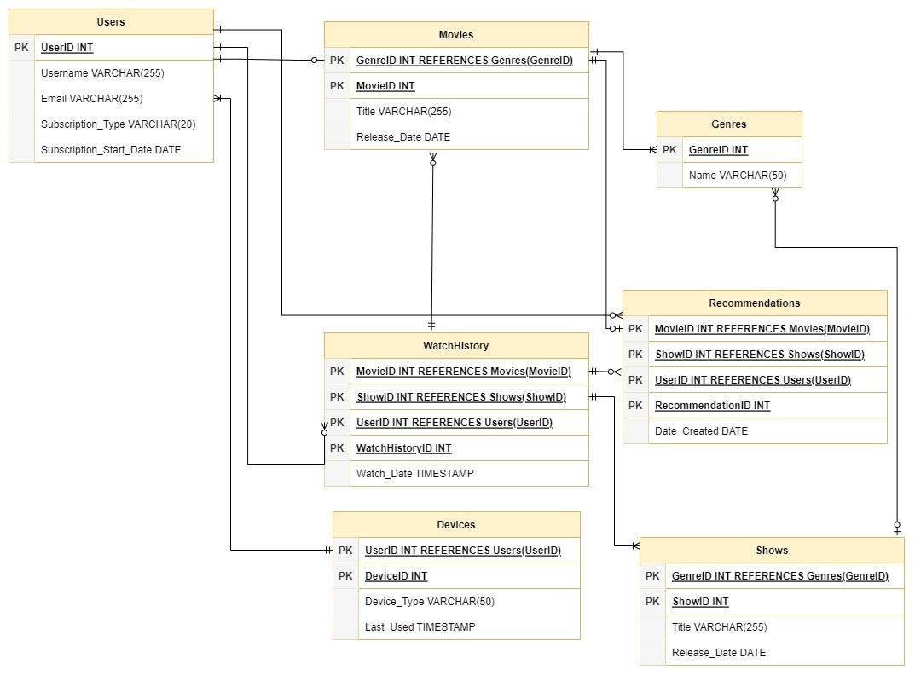

### **Conclusion:**

In this case study, we explored Netflix's schema and Entity-Relationship diagram, revealing the platform's intricate data model encompassing entities like users, shows, movies, genres, and recommendations. By addressing real-world challenges through personalised recommendations, seamless streaming, and a user-friendly interface, Netflix has redefined entertainment consumption. The schema, with its user-centric design, captures essential user information, showcasing a commitment to dynamic and personalised streaming experiences. The Entity-Relationship diagram visually illustrates the platform's complex yet efficient connections, emphasising how Netflix effectively manages user interactions and content delivery. With additional entities like Watch History, Device, Rating, and Bookmark, the schema gains depth, providing a comprehensive view of the Netflix user experience. Overall, Netflix's success stems from its innovative schema design, setting new standards in the streaming industry by offering a diverse, engaging, and seamlessly functional platform.